Answers to questions raised at the HRBPP ‘Changing Workplace’ webinar

How productivity was measured in the McKinsey research
McKinsey Research- They mention that productivity was measured based on effective potential- and effective potential was defined as ‘includes only those activities that can be done remotely without losing effectiveness. Model based on more than 2,000 activities across more than 800 occupations.’
They used MGI’s workforce model based on the Occupational Information Network (O*NET) to analyze more than 2,000 activities in more than 800 occupations and identify which activities and occupations have the greatest potential for remote work.
In the report they analyzed the potential for remote work—or work that doesn’t require interpersonal interaction or a physical presence at a specific worksite—in a range of countries, China, France, Germany, India, Japan, Mexico, Spain, the United Kingdom, and the United States.
They devised two metrics for remote work potential: the maximum potential, including all activities that theoretically can be performed remotely, and a lower bound for the effective potential for remote work, which excludes activities that have a clear benefit from being done in person (Exhibit 1).
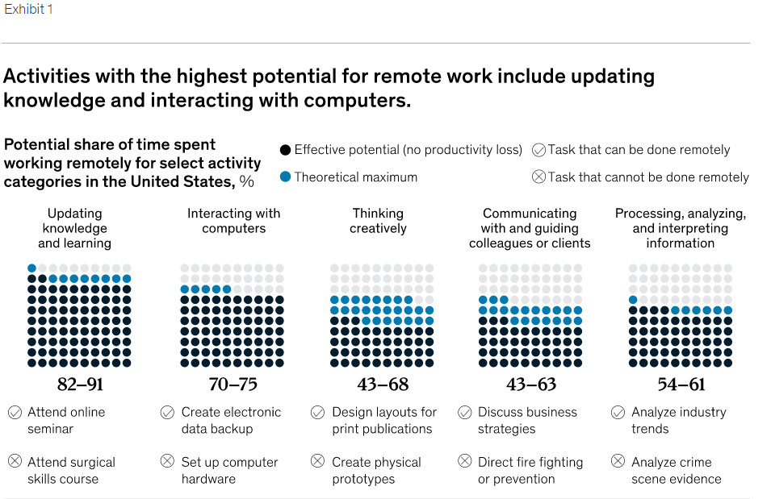
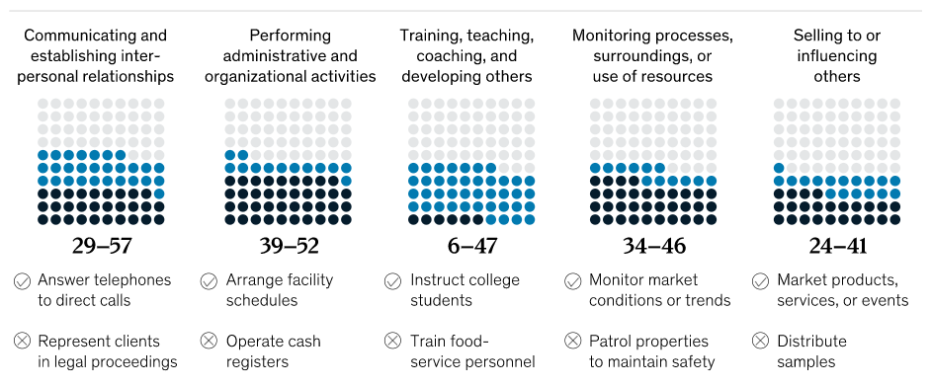

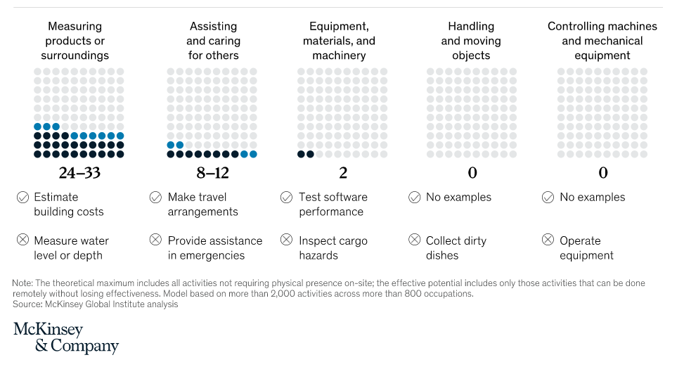
To determine the overall potential for remote work for jobs and sectors, we use the time spent on different activities within occupations. We find that remote work potential is concentrated in a few sectors. Finance and insurance has the highest potential, with three-quarters of time spent on activities that can be done remotely without a loss of productivity. Management, business services, and information technology have the next highest potential, all with more than half of employee time spent on activities that could effectively be done remotely (Exhibit 2).

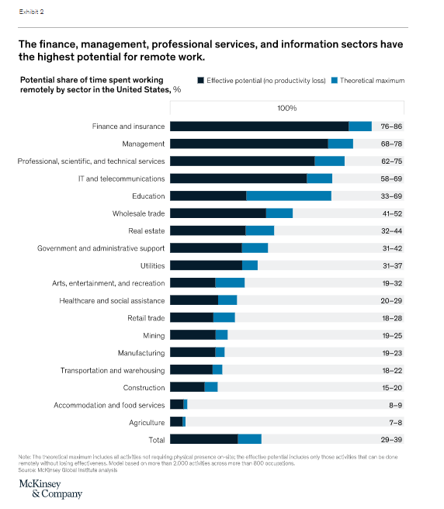

Health & Safety assessments for remote working
Points to consider:
- According to the HSE (Health & Safety Executive-UK)- As an employer, you have the same health and safety responsibilities for home workers as for any other workers.
When someone is working from home, permanently or temporarily, as an employer you should consider:
- How will you keep in touch with them?
- What work activity will they be doing (and for how long)?
- Can it be done safely?
- Do you need to put control measures in place to protect them?
The three areas they highlight is protecting lone workers, working with display screen equipment and stress and mental health.
- CIPD: Homeworking questionnaire here and HR-inform homeworking guide here

- According to The Legal Partners- They advise that a formal letter be sent to home workers (including a home working policy) and risk assessment with details of the home working arrangement.

Steps to be taken by the employer:
- Employers should be clear about who in the organisation is responsible for managing health and safety risks (While this will often fall within HR’s remit, this isn’t always the case and firms need to avoid a situation where no one is taking charge). The best solution is likely to be for both parties to participate in the assessment, with a regular checking or review role for the employer.
- Check your employer’s liability insurance covers employees working from home. Make sure your actions (or any lack of action) don’t invalidate the insurance.
- Remind the homeworker that they must have consent from their mortgage provider to work from home.
- Effective communication is key as given the nature of remote work means employers are now largely reliant on employees to take the steps needed to mitigate many risks.
- Staff must be properly informed of a full range of risks in a home working environment and how these can be addressed, as well as what equipment the employer is prepared to provide to help.
- Companies should continue to follow good practice through the provision of equipment, training, instruction and supervision to reduce the risk of litigation.
- Employers that don’t have in-house occupational health expertise should make sure their HR teams have the relevant qualifications, skills and experience.
- Training and supporting line managers to manage remote workers is also important.

